- Calculate the slope of the line that connects the points (2, -3) and (-4, 5). m = __________

- Calculate the slope of the line represented by the equation $2y−6x=\text{10}$. m = __________

- Calculate the slope of a line that is perpendicular to the line $3y=2x−6$. m = __________

- Calculate the slope of the line that connects the points (-5, 1) and (-7, -9). m = __________

- Calculate the slope of the line represented by the equation $3x−4=2y−1$. m = __________

- Calculate the slope of a line that is perpendicular to the line $y−5=\frac{1}{3}x−4$. m = __________

Directions: Calculate the slopes of the lines represented by the graphs.

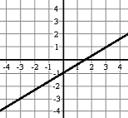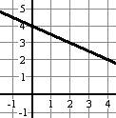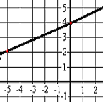

m = _______________ m = _______________ m = _______________ m = _______________

